Contents
1. Annual Audit Planning information 2
2. ExAnte Assurance Heatmap 2
3. Organisational (optional) 3
4. Audit Object L2 actualization 6
5. Handling of confidential data during the audit 7
6. General controls approach 7
7. Process based information 8
7.1. Compensation and Benefits 8
7.2. Governance and HR policies 18
7.3. Merit process for Board Members and executives 21

Annual Audit Planning information
Compensation and benefits
Risk Assessment | Low
Relevant for LE | DBAG, ECAG, CH, CI, CBL, CS, CBF, LuxCSD, Eurex Repo, EFAG and CFCL
Changes to RCA | N/A
L2 Additional info | N/A

 | DBAG | ECAG | CBF | CBL | CFCL
IA Judgement | Low | Low | Low | Low | Low
Regulatory required audit frequency | Yearly based on:  - CSSF Circular 10/437  - Regulation on the Supervisory Requirements for Institutions’ Remuneration Systems (InstitutsVergV  - EBA-RTS for risk takers  - Regulation on Supervisory Requirements for Remuneration Systems of Medium-Sized Securities Institutions (Wertpapierinstitutsvergütungsverordnung)
Comment | N/A | N/A | N/A | N/A | N/A

Governance HR Policies
Risk Assessment | N/A
Relevant for LE | DBAG, ECAG, CH, CI, CBL, CS, CBF, LuxCSD, Eurex Repo, EFAG and CFCL
Changes to RCA | From audit conclusion of previous audit
L2 Additional info | Process added as part of the 2024-029 Audit conclusion. No previous audits

 | DBAG | ECAG | CBF | CBL | CFCL
IA Judgement | N/A | N/A | N/A | N/A | N/A
Regulatory required audit frequency | N/A | N/A | N/A | N/A | N/A
Comment | Process added as part of the 2024-029 Audit conclusion. No previous audits

Merit process for Board members and executives
Risk Assessment | N/A new process added in 2025
Relevant for LE | DBAG, ECAG, CH, CI, CBL, CS, CBF, LuxCSD, Eurex Repo, EFAG and CFCL
Changes to RCA | N/A new process added in 2025
L2 Additional info | New process added in 2025. No previous audits

 | DBAG | ECAG | CBF | CBL | CFCL
IA Judgement | High | High | High | High | High
Regulatory required audit frequency | N/A | N/A | N/A | N/A | N/A
Comment | New L2 has been set up to separate the employee merit process to Board Members and Executives from the L2 Compensation and benefits In 2025, the DBAG Executive Board explicitly requested a comprehensive end-to-end review of the board and executive merit process by internal audit. Further, IA will assess and document, during the audit conclusions phase, how to incorporate this process in the regular Human Resources audit reviews.

ExAnte Assurance Heatmap
Most recent Ex-Ante Heatmap indication of residual risk (forward looking view)
ExAnte Assurance Heatmaps

HR
Legal entity | Q1 2024 | Q3 2024 | IA comments
DBAG | Low | Low | Ok no change
ECAG | Low | Low | Ok no change
CBF | Low | Low | Ok no change
CBL | Low | Low | Ok no change
CFCL | Low | Low | Ok no change
EFAG | Low | Low | Ok no change
ExR | Low | Low | Ok no change

Strategy and Corporate Governance (including Corporate office)
Legal entity | Q1 2024 | Q3 2024 | IA comments
DBAG | Low | Low | Ok no change
ECAG | Low | Low | Ok no change
CBF | Low | Low | Ok no change
CBL | Low | Low | Ok no change
CFCL | Low | Low | Ok no change
EFAG | Low | Low | Ok no change
ExR | Low | Low | Ok no change

Financial Accounting and Controlling
Legal entity | Q1 2024 | Q3 2024 | IA comments
DBAG | Medium | Low | Change due to remediation of number of internal audit findings
ECAG | Medium | Low | Change due to remediation of number of internal audit findings
CBF | Medium | Medium | Ok no change
CBL | Medium | Medium | Ok no change
CFCL | Medium | Medium | Ok no change
EFAG | Medium | Low | Change due to remediation of number of internal audit findings
ExR | Medium | Low | Change due to remediation of number of internal audit findings

No specific risks identified. No further tests added to the RCA

Organisational (optional)
Human Resources (HR)
Human Resources (HR) belongs to the Deutsche Börse Group (DBG) “Governance, People & Culture” division, reporting to Heike Eckert (as Member of the DBAG Executive Board).
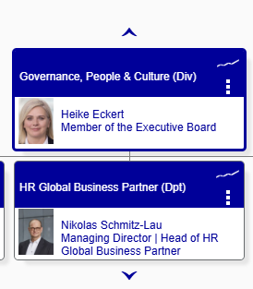
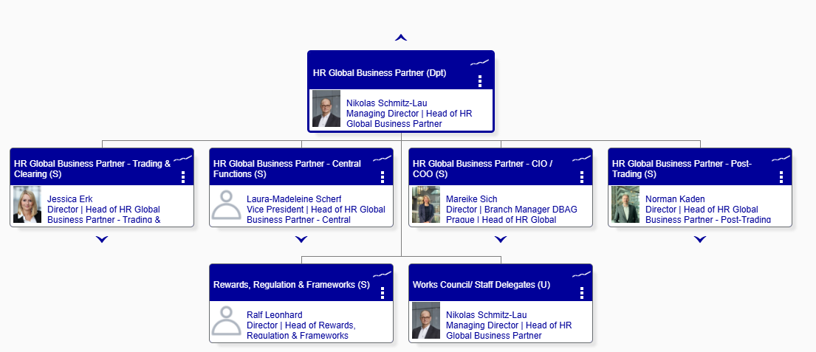
Controlling
Group Controlling provides reporting and controlling systems, which ensure transparency of financial business results on Group and business segment and company level. Furthermore, the section designs and accompanies the management process of budget planning & forecasting, resulting in effective steering mechanisms.
HR Controlling is a unit under Group Controlling, responsible for staff cost accounting (accrual management for Pensions, Bonus, Share Based Payments, flextime/holidays, etc.) and staff cost controlling (forcasting, budgeting, position plan maintenance, deviations analysis of costs and FTEs).
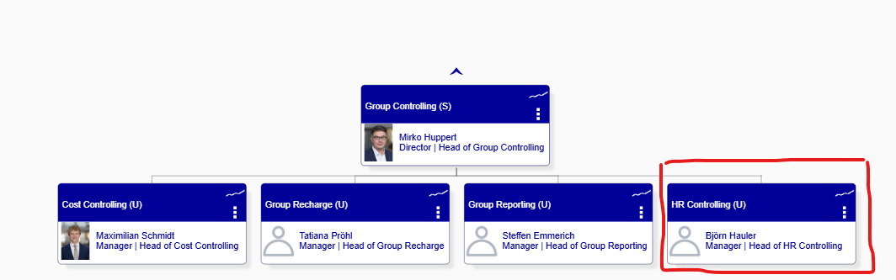

Group Compensation Officer (entities imoacted: CBL, CBF, CH, LuxCSD, ECAG):
The Group Compensation Officer shall perform the duties according to InstitutsVergV and as mandated by the relevant Executive Boards. The Compensation Officer has a direct functional and disciplinarian reporting line to the Executive Boards and a direct functional reporting line to the Remuneration Committees resp. Supervisory Boards. He serves primarily as an "instrument" of the Remuneration Committee of the Supervisory Board and, in the operational area of the Institution, is intended to perform the task of continuously monitoring the design of the remuneration systems for all employees, as well as the implementation of the remuneration systems for all employees. This is intended to enable the Supervisory Board / Remuneration Committee to perform its supervisory duties. In addition, due to his expertise and practical relevance, the remuneration officer naturally acts as the first point of contact for the supervisory authority in remuneration matters.
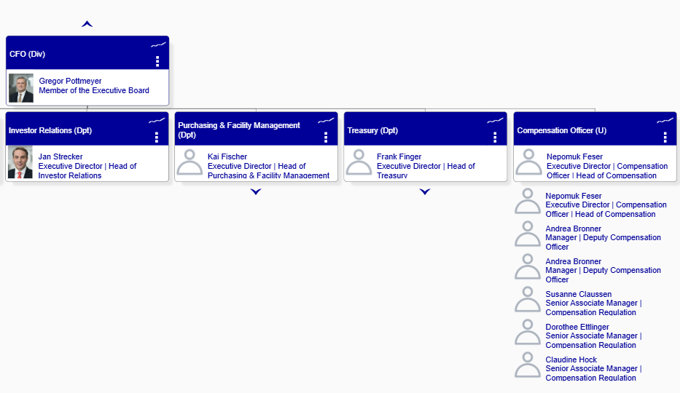

Corporate Office / Chairman’s Office
The Corporate Office section manages board and committee meetings of DBAG and certain subsidiaries. Moreover, they are responsible for the organisation and implementation of corporate governance processes at DBAG and to standardise them within DBG.
Chairman’s Office is a Corporate Office section’s unit. It is responsible for the remuneration system of the members of the Executive and Supervisory Board members of DBAG and prepares regular reports such as the Report of the Supervisory Board, the Remuneration Report, the Declaration of conformity and the Corporate Governance Report.
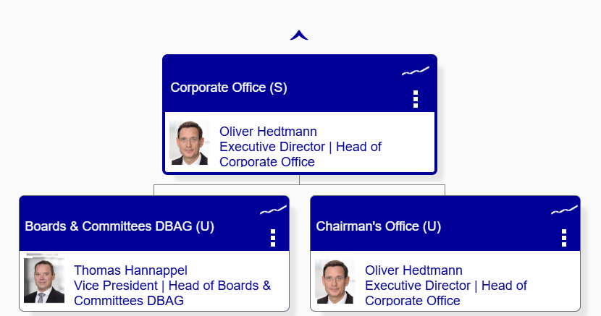

For further details on the organizational structure related to sub-processes in scope, refer to section 7.

Market Data + Services (MD+S)
Market Data + Services provides financial market participants around the world with proprietary market data from DBG's Xetra and Eurex trading platforms, as well as data from our cooperation partners. However, in the context of the Merit process for Board Members and Executives, the team is responsible for providing key inputs, e.g. Total Shareholders Return figures. MD+S is under the responsibility of Thomas Book in the Trading & Clearing division and is headed by Alireza Dorfard.
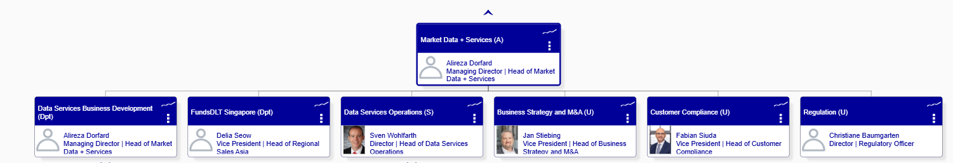

Audit Object L2 actualization
Human Resources (HR)
Golden Source L2 processes: | ICS GRC process bundles:
Compensation and benefits | P_DBAG_SU_3.3_Comp & Ben  SP_DBAG_SU_3.3.1_Merit-Bonus Salary Pr  SP_DBAG_SU_3.3.3_Annual Risk Taker Ana  SP_DBAG_SU_3.3.4_Ongoing Risk Taker An  SP_DBAG_SU_3.3.5_G - Pension Commitment  SP_DBAG_SU_3.3.6_G - Deferred Compensati  SP_DBAG_SU_3.3.7_L - Pension Fund  SP_DBAG_SU_3.3.8_L - Pension Fund La Lux  SP_DBAG_SU_3.3.9_P - Pension Fund Contri  SP_DBAG_SU_3.3.10_Suitability Check Key  SP_DBAG_SU_3.3.11._Malus Process  SP_DBAG_SU_3.3.12_Group Share Plan Proce  SP_DBAG_SU_3.3.13_Extraordinary Salary A
Governance HR Policies | No specific ICS process has been identified
Merit process for Board members and Executives | P_DBAG_SU_3.3_Comp & Ben  SP_DBAG_SU_3.3.2_Merit-Bonus Process E
Controlling
Golden Source L2 processes: | ICS GRC process bundles:
Merit process for Board members and Executives | P_DBAG_MA_3.6_Planning & Control Cycle  SP_DBAG_MA_3.6.7_Staff Costs Controlling
Corporate office
Golden Source L2 processes: | ICS GRC process bundles:
Merit process for Board members and Executives | P_DBAG_MA_1.3_Corporate Office  SP_DBAG_MA_1.3.3.1_Corporate Governance  SP_DBAG_MA_1.3.1.3_Directors Dealings SP_DBAG_MA_1.3.1.6_AGM
MD+S
Golden Source L2 processes: | ICS GRC process bundles:
Merit process for Board members and Executives | SP_DBAG_CO_3.2.1.2_Setup releases  SP_DBAG_CO_3.2.1.4_Monitoring and Assura  SP_DBAG_CO_3.2.1.7_Data Entry  SP_DBAG_CO_3.2.2.9_Financial Close

Handling of confidential data during the audit
During an audit engagement, we are committed to ensuring the confidentiality and security of all sensitive information. To achieve this, we will implement the following measures:
- Anonymization: All documents and calculation files will be anonymized to remove personally identifiable information (PII) such as names, and other sensitive data.
- Data Minimization: We will reduce the amount of documentation containing confidential data to the minimum necessary for the audit, ensuring only essential information is retained.
- Secure Storage: Confidential data will be stored securely, with access restricted to authorized personnel only.
- Compliance: All handling of confidential data will comply with relevant data protection regulations and organizational policies.

By adhering to these practices, we aim to protect the privacy and integrity of all confidential information throughout the audit process by having access to sensitive data only when strictly relevant for achieving the adequate coverage and testing.

General controls approach
During the initiation panel on February 26, 2025, it was agreed that General Controls testing will not be in scope of this audit due to the following:
- Currently, the topic of General Controls is being reviewed as part of a special audit (2025-024 General Controls) aiming to re-define IA’s approach to reviewing such controls and address issues in one centralized audit
- The scope of the 2025-051 audit is limited to Remuneration, Compensation and Benefits and Merit processes.

Where available, these will be reviewed during preparation phase to ensure any potential risks are captured.

Process based information

Compensation and Benefits
Topic | Review and results
Process description | Compensation & Benefits process includes:  - Merit, bonus, salary and malus process for staff, executives, risk takers (note: the process for executives is reviewed as part of a dedicated L2 – Merit for Board members and Executives in section 7.3 of this document)  - Annual and ongoing risk taker analysis  - Pension fund and pension commitments for Germany and Luxembourg  - Pension Fund Contribution Process Prague, which was audited in 2024-022 Branch Prague audit.  - Suitability assessment for Key Function Holders  Bonus Process Executives and Risk Taker – The process is performed once a year and contains the bonus decisions and allocations for Executives and Risk Takers. For details, refer to section 7.3 of the BCA.  Malus Process – The process covers malus assessment for Risk Takers in line with regulatory requirements. The Main Malus Process covers an assessment by the Compensation Planner and an overall assessment which is prepared by the Main Malus/Clawback Meeting. Process conducted on a yearly, regular basis.  Tools: SAP SuccessFactors – Compensation - Malus/Clawback Assessment  Bonus & Salary Process Staff without Risk Taker  The process is performed once a year and includes the bonus and salary increase decisions and allocations for Staff without Risk Taker as well as the proposal for Level 2/ Level 3 promotions. The process starts with the preparation of the 100% bonus budget calculation for the ExBo decision on bonus pay-out ratio and therewith the bonus budgets for Staff without Risk Taker, which is usually taken at the end of the financial year. After the allocation phase, based on preliminary total amount decisions and the pay-out, the process ends after the review of the final year-end figures and the final total amount decisions by regulated entities.  Tools: Staff Merit Tool (SSF-module Compensation) - The bonus proposals are collected with the tool, which also checks bonus as well as salary increase budget overruns based on the proposals by the Compensation Planner.  Extraordinary Salary Adjustment Process  The process starts with the creation of the extraordinary salary request by the Line Manager and closes with the signed Employee Information Letter and the interface to the HR process regarding the payroll. The process includes the creation of the request, a check of the reason and amount against HR internal guidelines (as applicable), an internal/external benchmark check (if requested) and a check of the budget by the respective businesses. The process includes additional requirements for Luxembourg.  Tools: MS Outlook, SuccessFactors  Deferred Compensation Request Process  The process is performed annually and includes the update and publishment of the Participation Form “Deferred Compensation”, the request about deferred compensation by the respective employee, a check of the request, as well as the recording of the deferred data into SAP. The process has an interface to the HR processes “3.2 Bonus Process Executives and Risk Taker” and “3.1 Bonus Salary Process Staff without Risk Taker”.  Annual and Ongoing Risk Taker Analysis  The Annual Risk Taker Analysis serves to identify employees whose professional activities have a material impact on the institution’s risk profile (“Risk Taker”) and who are subject to specific requirements on remuneration. The process must be conducted on a regular basis and includes the methodology definition in line with relevant requirements, the Risk Taker identification in line with relevant criteria, the approval by the relevant governing bodies and the implementation of the results (i.e., administrative actions taken). The process stakeholders are the Compensation Officer, Control Functions and other support functions. The responsibility lies with the Executive Board (or equivalent). The analysis is conducted by HR Rewards, Regulation & Frameworks.  Ongoing Risk Taker Analysis serves to streamline the Annual Risk Taker Analysis. The process is conducted on a risk-basis and initiated by a triggering event, e.g. promotions, reorganizations, company exits or new hires. The process stakeholders are the Compensation Officer, HR Managers and the Line Manager. The analysis is conducted by Rewards, Regulation & Frameworks in alignment with the Compensation Officer.  LEs in scope: CBF, CBL, LuxCSD, CH, ECAG, CFCL.  Group Share Plan  DBAG determines and offers for the respective year a discount on the share price to eligible DBG employees. The process is triggered annually with the decision of the DBAG ExBo on the implementation of a further tranche of the GSP, which is usually taken in the first half of the year. HR prepares several documents to enable the employees to subscribe for the GSP. A third-party provider is involved to process the GSP. The process contains the check of eligible employees, cost calculations as well as several internal alignments with applicable stakeholders (e.g., Legal, Tax, third-party provider). After the employee has accepted the GSP offer, the subscribed DBAG shares are booked into the employees' securities accounts and the benefit in kind is settled through the payroll.  Pension Commitment including Pension Rep Process Germany  The process is triggered by either an employee leaving, an employee being transferred to another legal entity or due to the annual inventory process for all pension schemes starting on 30th of September. The process includes the quarterly reporting of transfers between legal entities (a), the check of pension schemes and the creation of the non-forfeitability certificate (b), and the creation of the Inventory List, the creation and approval of the Expertise and the communication of the Account Statements to the employees (c).  This process is only applicable for the German entities.  Pension Fund Process Luxembourg  The process includes processing of the Clearstream Luxembourg Pension Fund (CLPF) in Luxembourg. The process is triggered by either an employee leaving, the quarterly report or the annual processing in March. The CLPF is a closed pension fund, reserved for members and beneficiaries who have signed an employment contract with a contributing company before 1 January 2019 and who are employees or former employees of one of the Contributors. The process includes the creation of the Pay-out Request Form for employees leaving; the creation of the Quarterly Pension Report; the creation of the annual statements.  This process is only applicable for Luxembourg.  Pension Funds La Luxembourgeoise Process  The process describes the day-to-day activities regarding both the additional employer pension scheme and the voluntary personal contribution scheme with La Luxembourgeoise. The process is applicable for employees under Clearstream Banking S.A., Clearstream Fund Centre S.A., Clearstream Services S.A. and Clearstream International S.A., hired as of Jan 1st, 2019, at the earliest (affiliates).  Suitability assessment  The purpose of the Suitability Check for Key Function Holder is to ensure that (prospective) Key Function Holders of the companies in scope are suitable in terms of reputation, honesty, integrity, knowledge, skills, and experience. The process is guided by a global Policy (not location nor Company-specific) and a Side Letter, adapted to the local and regulatory background of each Company. The Side Letters include the description of each Key Functions, as well as a general process for the Suitability Assessments. HR is responsible for the content and review regarding assessment of suitability of the Key Function Holders.  LEs in scope: ECAG, CH, CBL, CBF, LuxCSD, Eurex Repo, CFCL.  The respective Corporate Office and Boards & Committees functions are responsible for the Policy content and review of its elements regarding the assessment of suitability of members of the Governing Bodies (in scope of the 2024-051 Corporate Governance audit).  Key risks in relevant processes refer to wrong and unauthorized payments, fraud, errors in calculations and accruals, regulatory non-compliance, inadequate capturing and analysis of risks. Designed controls are based on 4-eyes principle, preventive, mostly manual and executed ad hoc or annually.  No changes in the process design and execution since the previous HR audit.
Relevant Organizational structure | The Rewards, Regulation & Frameworks (FPD) section consists of 13 employees, mostly level 3 and 4 and 1 student. No major organisational changes except additional FTEs since previous audit. Key contacts:  - Christoph Bosler – Vice President – located in Eschborn  - Nicole Dittrich – Vice President – located in Eschborn  - Kerstin Rau – Vice President – located in Eschborn  - Julie Bocquet – Senior Associate – located in Luxembourg
Key business indicators | Outsourcing related KPIs listed in Data from Outsourcing.  Workforce Dashboard quarterly reporting to DBAG ExBo.  Conclusion: No specific risks identified that would require additional testing procedures.
Relevant legal and regulatory requirements | - Commission Delegated Regulation (EU) 2021/923 of 25 March 2021 supplementing Directive 2013/36/EU of the European Parliament and of the Council with regard to regulatory technical standards setting out the criteria to define managerial responsibility, control functions, material business units and a significant impact on a material business unit’s risk profile, and setting out criteria for identifying staff members or categories of staff whose professional activities have an impact on the institution’s risk profile that is comparably as material as that of staff members or categories of staff referred to in Article 92(3) of that Directive  - Regulation (EU) No 2019/876, also known as CRR II  - Directive 2019/878/EU, also known as CRD V  - Law of 5 April 1993 on the financial sector  - Circular CSSF 22/797 Application of the Guidelines of the European Banking Authority on sound remuneration policies under Directive 2013/36/EU (EBA/GL/2021/04)  - CIRCULAR CSSF 10/437  - MaRisk 4.3.2, BT 3.2, BT3.3 and BT 3.4  - Regulation on the Supervisory Requirements for Institutions (Institutsvergütungsverordnung – InstitutsVergV), until 31 Dec 2024  - FAQs on the InstitutsVergV (BaFin’s FAQs supplement the EBA Guidelines and flesh them out, particularly in areas that are not covered by the EBA Guidelines or have been implemented differently in Germany as part of the proportionality concept), new as of 1 Jan 2025  - Minimum Wage Act (Germany)  - General Equal Treatment Act (AGG)  - Protection Against Unfair Dismissal Act
Relevant internal requirements | Policies:  - Remuneration Policy Clearstream Group (CH CBF)  - Remuneration Policy Clearstream Group Lux (CBL CI CS)  - Remuneration Policy ECAG  - Remuneration Policy Eurex Repo  - Remuneration Policy LuxCSD  - Remuneration Policy CFCL  - Remuneration Policy for Group Risk Takers DBG  - Policy for the assessment of the suitability of Members of the Management Body and Key Function Holders + Side letter for ECAG, ExR, CBF, CBL, CFCL, CH, LuxCSD (confidential)  Procedures:  - Bonus Salary Process Staff without Risk Taker  - Deferred Compensation Request Process  - Group Share Plan  - Extraordinary Salary Adjustment Process  - Annual Risk Taker Analysis  - Ongoing Risk Taker Analysis  - Pension Commitment including Pension Rep Process Germany  - Pension Fund Process Luxembourg  - Pension Fund La Luxembourgeoise Process  - Suitability Check for Key Function Holder
IT environment + Cloud services | The following applications have been mapped to this L2:  AID154 SAP ERP – application used for a number of HR processes such as recruiting training, payroll and benefits.  AID2077 MPLEO – removed and no longer in use; a digital and modular solution that covers all HR aspects. From managing absences and presences to expense notes, payroll, talent & performance management.  AID2157 PayAnalytics - a software solution to conduct salary review and analysis, measure gender and other demographic discrepancies in pay, and offers recommendations on how to close pay gaps.  IA noted one additional application in use - SAP SuccessFactors (AID 0306), used for talent and performance management.  Refer to the below sections “Defined test” for the defined IT applications approach.
ESG | During the mapping of ESG aspects, the following has been defined as relevant for this L2:  please refer to section Defined test for audit procedures defined
  ESG topics | Comments/ suggested approach
  Diversity and inclusion (gender parity, pay equity). | To be assessed as part of the L2 Compensation and benefits
  Employee working conditions | To be evaluated overall during the audit. No need for dedicated L3
  Risk of social washing | I suggest to create an L3 in the Compensation and benefits “ESG Internal and External reporting” and to evaluate the risk of social washing there together with the Transparency in reporting to regulators and KPIs consideration points below
  KPIs considered : e.g. Employee satisfaction rate, Percentage of women in leadership positions, Number of funded social initiatives, Portion of variable compensation tied to ESG goals | Refer to Risk of social washing point above
  Transparency in reporting to regulators | Refer to Risk of social washing point above
  Developing and enforcing ESG policies (e.g., inclusion policies, Conducting ESG training for employees and management. | We can cover this point as part of the L2 Compensation and benefits/ L3 Bonus & Salary Process Staff without Risk Taker (staff L1-L4, 5 and 5*)
Available Risk Management Data | Compensation and benefits process is not mission critical. Therefore, no BCPs are required.  Relevant OpRisk scenarios cover confidentiality breach and data maintenance errors:  ▪ RISK/50000199 ORS_C_EP026 - Confidentiality Breach  ▪ RISK/50000223 ORS_DBAG_EP001 - Confidentiality Breach  ▪ RISK/50031974 ORS_C_SD039 - HR data maintenance errors  ▪ RISK/50031996 ORS_DBAG_SD014 - HR data maintenance error  Information from SAP GRC Process Map and RCM  Conclusion: No specific risks that would require dedicated tests have been identified.
  Process | Inherent risk | Residual risk
  SP_DBAG_SU_3.3.1_Merit-Bonus Salary Pr | Medium | Negligible
  SP_DBAG_SU_3.3.3_Annual Risk Taker Ana | Medium | Negligible
  SP_DBAG_SU_3.3.4_Ongoing Risk Taker An | Low | Negligible
  SP_DBAG_SU_3.3.5_G - Pension Commitment | Low | Negligible
  SP_DBAG_SU_3.3.6_G - Deferred Compensati | Low | Negligible
  SP_DBAG_SU_3.3.7_L - Pension Fund | Low | Negligible
  SP_DBAG_SU_3.3.8_L - Pension Fund La Lux | Low | n/a
  SP_DBAG_SU_3.3.9_P - Pension Fund Contri | Low | n/a
  SP_DBAG_SU_3.3.10_Suitability Check Key | Negligible | Negligible
  SP_DBAG_SU_3.3.11._Malus Process | Negligible | Negligible
  SP_DBAG_SU_3.3.12_Group Share Plan Proce | Negligible | n/a
  SP_DBAG_SU_3.3.13_Extraordinary Salary A | Negligible | n/a
Data from Compliance | Germany: No findings identified in Compliance reports relevant to this L2. No controls planned for 2025.  Luxembourg: No findings identified in Compliance reports relevant to this L2. No controls planned for 2025.  Conclusion: No specific risks or test defined
Data from Outsourcing | Most Compensation & Benefits sub-processes for legal entities in scope are outsourced to DBAG. Compensation & Benefits services are included in the respective SDS’s with the following KPIs:  - Control of Regulatory Processes - A valid Remuneration Policy (as applicable) is in place and a yearly review/renewal of the Remuneration Policy regarding regulatory requirements on remuneration was conducted. The Remuneration Policy shall be updated once a year. It shall be assessed on a monthly basis if a valid policy is in place.  - Execution of Remuneration Process for Executives and Risk Takers (details in section 7.3 of the BCA).  - Execution of Remuneration Process for Staff (Merit Review) - Resolution of ExCo regarding Staff Merit of relevant Financial Year is taken (expected in December of related year). Under consideration of the respective regulatory requirements.  Conclusion: No specific risks that would require dedicated tests have been identified.
Data from Internal Audit | Conclusion: No specific risks that would require follow-up have been identified.
  2024-029_F17 - Inaccurate and incomplete ICS Process Maps | S1 | closed
  2024-022_F01 - Weaknesses in the Pension Fund process for Prague employees | S2 | closed
Data from External Audit | No external audit findings have been identified as relevant for this L2.
Relevant Future notes | 241119104921: By 7 June 2026 all the companies in Europe must comply with the "Directive (EU) 2023/970 of the European Parliament and of the Council of 10 May 2023 to strengthen the application of the principle of equal pay for equal work or work of equal value between men and women through pay transparency and enforcement mechanisms (Text with EEA relevance)". How are we preparing the be compliant?  https://eur-lex.europa.eu/EN/legal-content/summary/equal-pay-for-equal-work-or-work-of-equal-value-between-men-and-women-rules-on-pay-transparency.html
Outcome of initiation panel (as applicable) | No specific points noted for this L2 during the initiation panel.
Conclusion: Risk overview | Risk assessment  IA assesses the risks for this L2 as Medium residual risk based on the review/preparation done so far. The assessment is driven by High risk of operational errors, fraud and non-compliance in the Merit process for staff without risk takers. IA assesses that there is a Medium risk of regulatory non-compliance in Risk Taker Analysis. Risks in the remaining sub-processes are assessed as Low.  Applicable risk categories  - Counter-party (re)action: B7-Reputational Risk, B12-Vendor Dependency Risk  - Compliance Risk: O1-Regulatory Compliance Risk, O2-Other Compliance Risk, O5-Criminal Offence (incl. Fraud) Risk, O7-Privacy Risk  - Information Security Risk: O12-Internal Information Security Risk  - Legal Risk: O19-Private Settlement & Litigation Risk  - People Risk: O25-Human Error Risk, O26-Employment Practices Risk  - Processing & Execution Risk: O28-Processing and Execution Risk  - Secondary Reputational Risk: O31 - Secondary Reputational Risk  - Third Party Risk: O32-In-/Outsourcing and External Procurements Risk, O33-Third Party Compliance Risk  Scoping  Previous audit (2024-029 HR) scope:  - Merit-Bonus Salary Process Staff w/o Risk Taker - Design and operating effectiveness  - Merit-Bonus Process Executives and Risk Taker - Design and operating effectiveness  - Annual Risk Taker Analysis - Design and operating effectiveness  - Ongoing Risk Taker Analysis - Design and operating effectiveness  - Pension Commitment incl. Pension Rep Process GER - Design effectiveness  - Deferred Compensation Request Process - Design effectiveness  - Suitability Check Key Function Holder - Design and operating effectiveness  - Malus Process - Design and operating effectiveness  - Group Share Plan Process - Design effectiveness  - Extraordinary Salary A - Design effectiveness  Audit scope:  - Bonus & Salary Process Staff without Risk Taker (staff L1-L4, 5 and 5*) – control design and control operating effectiveness (all LEs)  - Merit process for executives and risk takers – refer to section 7.3 of the BCA  - Malus process – control design effectiveness (for all LEs)  - Annual and ongoing risk taker analysis – control design and control operating effectiveness (for all LEs)  Out of fieldwork scope  - General controls, as those were covered in the previous 2024 audit and there is a dedicated General Controls audit in 2025.  - Pension Fund Contribution Process Prague, which was audited in 2024-022 Branch Prague audit.  - Due to low risk, control operating effectiveness for the following processes: Extraordinary Salary Adjustment Process, Deferred Compensation Request Process, Group Share Plan, Malus process, Pension fund and pension commitments for Germany and Luxembourg, Suitability assessment for Key Function Holders
Data Analytics | No possibility for data analytics identified at this stage for this L2.
Defined test | Bonus & Salary Process Staff without Risk Taker (staff L1-L4, 5 and 5*)  Control design effectiveness  - Review relevant policies and procedures to identify key requirements, process steps and controls to ensure same are kept up-to-date  - Validate that merit rules are in line with relevant policies, procedures and guidelines  - FuN 241119104921: By 7 June 2026 all the companies in Europe must comply with the "Directive (EU) 2023/970 of the European Parliament and of the Council of 10 May 2023 to strengthen the application of the principle of equal pay for equal work or work of equal value between men and women through pay transparency and enforcement mechanisms (Text with EEA relevance)". How are we preparing to be compliant? https://eur-lex.europa.eu/EN/legal-content/summary/equal-pay-for-equal-work-or-work-of-equal-value-between-men-and-women-rules-on-pay-transparency.html  - In the context of the gender parity and pay equity, inqure how is this covered in the applicable policies in place  Control operating effectiveness  - On a sample basis, validate that:  - Controls are executed and adequately documented  - Relevant data is uploaded in the tool  - Bonus calculation and accruals are accurate  - Bonus amounts in merit letters are in line with amounts sent to Payroll, accruals and decision documents  Malus process - Control design effectiveness  - Review the process in place to identify key process steps and controls.  - Walk through the process to validate the execution of key process steps and controls.  Annual and ongoing risk taker analysis  Control design effectiveness  - Review the process in place to identify key process steps and controls.  - Validate that the process is in line with regulatory requirements.  Control operating effectiveness  - On a sample basis, validate that:  - risk taker analysis documentation is complete  - relevant approvals are obtained  - controls were executed and documented  ESG internal and external reporting  X§x  IT applications:  AID154 SAP ERP  AID2077 MPLEO  AID 0306 SAP SuccessFactors  AID2157 PayAnalytics  - For the above applications, review the security documentation and ensure same is up to date  - Ensure roles and access rights are defined and there are no conflicting roles  - Ensure SoD is respected  - For AID2077, obtain migration and decommissioning concepts and review the completeness of the migrated functionality and data to the new systemReview the application functionality, in the context of the dedicated L3s

Governance and HR policies
Topic | Review and results
Process description | During the 2024 Human Resources audit, it was noted that “Annual Policy Review” has been removed as a sub-process in the process landscape. The sub-process was related to the review of all the HR-owned policies. Further, during the 2024 audit, it was noted that some of the HR-owned policies were not translated into procedures (for example Disciplinary Action Policy, Remove Working Policy Luxembourg, Anti- Harassment Policy, etc.)  Based on the above points noted, a new L2 process was created in the Audit Universe aiming to review the HR-owned policies and assess the need to translate these into sub-processes in the process landscape.
Relevant Organizational structure | Refer to section 3 of this document.  No specific roles and responsibilities have been identified for the update of the HR-owned policies
Key business indicators | No specific KBIs identified for this L2
Relevant legal and regulatory requirements | Article 26.2 of Regulation (EU) No 909/2014 (CSDR L1)  Article 36 of the Law of 5 April 1993 on the financial sector  CSSF Circular 12/522, article 74, 75  MaRisk AT4.3 and AT5
Relevant internal requirements | DBG Internal Control System (ICS) Policy
IT environment + Cloud services | No specific IT applications identified for this L2
Available Risk Management Data | No specific Risk Management data identified for this L2
Data from Compliance | No specific Compliance data identified for this L2
Data from Outsourcing | No specific data from outsourcing
Data from In ternal Audit | The following relevant finding has been raised as part of the 2023-041 Human Resources audit:
  Title of finding | Severity | Status
  Incomplete and/or outdated procedures for Merit and BVV processes | S1 | Closed
Data from External Audit | No data from external audits identified for this L2
Relevant Future notes | No relevant future noted identified for this L2
Outcome of initiation panel (as applicable) | As no specific risks have been identified related to this L2 and due to the focus of the audit on the compensation, benefits and merit process, the following has been agreed during the initiation panel:  - Policies and procedures related to the Remuneration, Merit process, Benefits, Malus process, etc. should be reviewed as part of this audit and be incorporated in their respective L2’s. No separate L2 Governance and HR Policies to be included in the RCA.
Conclusion: Risk overview | No specific risks identified for this L2
Data Analytics | Not applicable for this L2
Defined test | Out of scope for this audit. Therefore, no procedures for RCA defined

Merit process for Board Members and executives
Topic | Review and results
Process description | The Merit process aims at determining the variable component of the annual compensation of the Board Members and Executives. The Merit process is performed from October to April. It starts with the estimation of preliminary bonus based on the estimated target achievement and building of accruals for the pay-out at the end of the year. The relevant target achievements and final bonus budgets are reviewed at the beginning of the upcoming performance year. The process ends after the total amount decision by the boards, the allocation and the pay-out of the relevant bonus amounts (also including payments of granted but deferred bonus amounts from previous years).  Different compensation programs exist and apply within DBG:  - Individual target-based bonus and ATP (Aktien Tantieme Program) – Level 5 and 5*, non-risk taker – reviewed as part of the L2 Compensation and Benefits due to the similarities of the calculation L1-L4 non-risk-takers – all entities in scope of the audit  - RSU ("Restricted Stock Units") und LSI ("Long-term sustainable instrument") for Risk Takers (Variable Remuneration Scheme Risk Taker). Applicable to regulated entities in scope of the audit (except for ExR, as ExR was so far not obliged to identify Risk Takers) Performance Bonus Plan for Executives at level 6, non-risk taker. There are also several eligible 5* level employees - will be reviewed in this audit – relevant to DBAG and EFAG  - Performance Bonus Plan and Performance Share Plan for the Board Members of DBAG and EFAG - will be reviewed in this audit  Risks known to auditees are operational risks (human error risk, reputational risk, litigation risk), which could lead to erroneous compensation sums calculated and paid out. Besides, it might cause reputational risks and litigations, especially if substantial amounts are involved.
Relevant Organizational structure | The following stakeholders are involved in the process:  - HR Rewards, Regulations & Frameworks  - Group Controlling  - MD&A (for DBAG/EFAG)  - Corporate Office
Key business indicators | November and January Merit presentations to Executive Board(s), February presentation to the Supervisory Board.
Relevant legal and regulatory requirements | - The Remuneration Ordinance for Institutions (Institutsvergütungsverordnung – „InstitutsVergV“ (IVV), dated 15 July 2019 Wertpapierinstitutsgesetz (Remuneration Ordinance for Institutions dated 16 December 2013 as amended with Article 1 of the Ordinance, dated 15 July 2019)  - Interpretation Guide to the Ordinance on the Supervisory Requirements for Institutions’ Remuneration Systems (valid until end of 2024); BaFin has published questions and answers (FAQ) on the Remuneration Ordinance for Institutions (InstitutsVergV). They replace the previous interpretation aid. BaFin has set a transitional period until January 1, 2025, within which the supervised institutions must implement the requirements from the FAQs on the InstitutsVergV in their remuneration systems.  - Kreditwesengesetz (KWG, German banking act, regarding suitable salary of board members of banks or remuneration requirements for institutions which are referred in Insitutsvergütungsverordnung)  - BaFin Circular 06/2024 Minimum Requirements for Risk Management (MaRisk) AT 4.3 and AT 5
Relevant internal requirements | The following procedures are relevant for the Merit process for Board members and executives:  - Procedure Merit Review (SP_DBAG_MA_3.6.7.2.8.1_Merit Review), Version: 1.0 (Document owner: Controlling)  - Performance Share Plan, version 01.01.2020, 01.01.2019 and 01.01.2017 (Document owner: Corporate Office)  - Performance Bonus Plan, version 01.01.2023 (Document owner: Corporate Office)  - Procedure 3.2 Bonus Process Executives and Risk Taker (SP_DBAG_SU_3.3.2_Merit-Bonus Process Executives) (Document owner: HR Rewards, Regulations & Frameworks)  - Description Vergütungssystem für die Vorstandsmitglieder (DBG website)
IT environment + Cloud services | No IDP in use by HR Controlling and Corporate Office.  Group Controlling documents related to Merit process are stored on these drives:  S:\Misc\CO-Admin\CO-Admin\4000_Staff-Controlling\Merit Review\2024\2025_01_21_Merit Review 2024 - Actuals  S:\Misc\HRCO_HR  Executive and Risk Taker Merit Tool in Success Factors (SAP) is used for processing of bonus payments for executives and risk takers
Available Risk Management Data | N/A. Refer to section 6 of this document for the approach to General Controls
Data from Compliance | N/A. Refer to section 6 of this document for the approach to General Controls
Data from Outsourcing | Most Compensation & Benefits sub-processes within the for legal entities in scope are outsourced to DBAG. This also includes the Merit process.  The below KPI is defined in the SDSs and monitored on a quarterly basis:  - Execution of Remuneration Process for Executives and Risk Takers
Data from Internal Audit | No findings relevant to Merit process for Board Members and Executives.
Data from External Audit | No findings relevant to Merit process for Board Members and Executives.
Relevant Future notes | No relevant future notes identified.
Outcome of initiation panel (as applicable) | It was agreed that the review of the Merit process will be limited to the year 2024 as performance period for the Performance Bonus Plan and other short-term remuneration programmes and 5-year performance period 2020-2024 for the Performance Share Plan.
Conclusion: Risk overview | Overall risk assessment on L3 “Merit process for board members and executives” is assessed as high, considering a potential monetary and reputational impact of errors in the process.  The following main risks were identified considering the GRM risk taxonomy:  - Business Risk – Business Risk – B6 Regulatory Risk  Risk of not considering regulatory/law changes affecting the Merit process for board members and executives.  - Business Risk – Business Risk – B7 Reputational Risk  Reputational risk caused by various scenarios (i.e., leak of employee confidential information such as bonus and/or salary, delays and mistakes in the payments, etc.)  - Operational Risk - O19 Private Settlement & Litigation Risk  Risk of losses from private settlement or current or future litigations resulting from dissatisfied clients/ counterparties or other legal disputes  - Operational Risk – People Risk – O25 Human Error Risk
Data Analytics | Data analytics will not be applied to this process.
Defined test | Corporate Office (DBAG only)  Control design effectiveness:  - Inquire about the governance surrounding the remuneration scheme (PSP and PBP)- who are the stakeholders in the review/approval process, how often is the renumeration scheme reviewed. Ensure roles and responsibilities in the review/approval process are defined and clear.  - Ensure that current renumeration scheme was communicated at the AGM as required by the regulations.  - Ensure that the role of Corporate Office in the calculation and approval process of bonus amounts acc to PBP and PSP is formally defined, and respective controls are described.  Control operating effectiveness:  - Obtain the latest calculation of the PBP and PSP for the defined scope period and ensure that formulas are correct and there are no mistakes in linkage and source data  - Ensure that necessary approvals for calculation results by DBAG ExCo and Supervisory Boards have been obtained  - Ensure that 4ep controls over the calculations withing the Corporate Office are duly documented  HR Rewards, Regulations & Frameworks (for all LEs)  Control design effectiveness:  - Review process controls related to the Merit process  - Obtain procedures in place and ensure same are up to date  - Ensure that controls are in place to ensure data quality  - Take the new BaFin InstitutsVergV FAQs into account, particularly with regard to the intended adjustments which has to be done until January 2025 to revise the remuneration systems accordingly (For German regulated entities only)  Control operating effectiveness:  - For the controls identified, for the period under review, ensured same are executed and evidenced  Group Controlling (for all LEs)  Control design effectiveness:  - Review process controls related to the Merit process  - Obtain procedures in place and ensure same are up to date  - Ensure that controls are in place to ensure data quality  Control operating effectiveness:  - Review the set-up of calculation models for PBP and PSP to verify if the formulas and input data correspond to the plan design (IA DBAG only)  - Review the calculations and data input related to the performance year 2024 (PBP) and performance period end year (PSP). (IA DBAG only)  - Review the calculations and data input related to the performance year 2024 for other legal entities (Clearstream and ECAG)  Market Data + Services (DBAG only)  Control design effectiveness:  - Review process controls related to the Merit process  - Obtain procedures in place and ensure same are up to date  - Ensure that controls are in place to ensure data quality  Control operating effectiveness:  - For the controls identified, for the period under review, ensured same are executed and evidenced

